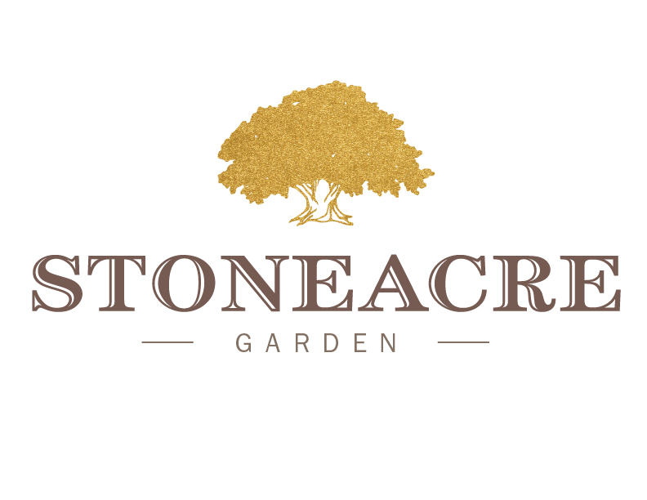
PSNC / Chinese Tea House Lunch
(Includes a non-alcoholic beverage and small dessert)

Lunch Entree
Guest’s Choice of One
Avocado Toast | Heirloom Tomatoes | Jalapeno | Radish | Mixed Greens
Kale Caesar | Miso Dressing | Lemon | Parmesan | Grilled Chicken
Tuna Poke Bowl | Edamame | Sesame | Radish
Seasonal Vegetable Quiche | Market Greens
Stoneacre BLT | Heirloom Tomato | Aioli | Bacon
Croque Monsieur | Ham | Gruyere | Parmesan

